

Mini Project Report: 08
Master of Computer Application – Data Science
Semester I

Subject: Front-End Frameworks and Technologies

Topic: : JavaScript Grade
Calculator
By
Name: ARBAB SUHAIL
Registration No: PROV/ASAC/MCA/7/26/082
Faculty Name: VEERA RAGHAV K
Faculty Signature:________________

Department of Computer Application
Alliance University
Chandapura – Anekal Main Road, Anekal
Bengaluru – 562 106

August 2026

INDEX
SL NO | NAME OF THE CONTENT | PAGE NO
1 | INTRODCUTION | 3
2 | INPUT CODE | 4
3 | CODE OUTPUT | 10
4 | CONCLUSION | 11

INTRODUCTION

The Student Grade Calculator is a simple web-based application developed using HTML, CSS, and JavaScript. HTML is used to create the form for entering the student’s name, registration number, and marks in HTML, CSS, and JavaScript.
CSS is used to style the form by adding borders, padding, margins, and proper alignment. JavaScript is used to calculate the total marks, average, percentage, grade, and pass or fail status based on the entered marks. The application also includes Check Result and Restart buttons. This project demonstrates the basic use of forms, CSS styling, JavaScript functions, conditions, and DOM manipulation to create an interactive student result system.

INPUT CODE
<!doctype html>
<html lang="en">
<head>
<meta charset="UTF-8" />
<meta name="viewport" content="width=device-width, initial-scale=1.0" /> <title>Student Result Dashboard</title>

<style> body { text-align: center; font-family: Arial, sans-serif;
}

form {
width: 450px; margin: 40px auto; padding: 25px; border: 2px solid black; border-radius: 10px; background-color: rgb(218, 241, 6);
}

h1 { margin-bottom: 25px;
}

label { display: inline-block; width: 130px; text-align: left; margin: 8px;
}

input { padding: 7px; margin: 8px;
}

button { padding: 8px 15px; margin: 15px 5px; }

#para { text-align: left; border: 1px solid black; padding: 15px; margin-top: 20px;
}
</style>
</head>

<body>
<form id="myForm">
<h1>Student Grade Calculator</h1>
<label>Student Name:</label>
<input type="text" name="n1" id="i1" />
<br />
<label>Student Reg:</label>
<input type="number" name="n2" id="i2" />
<br />
<label>HTML Marks:</label>
<input type="number" name="n3" id="i3" />
<br />
<label>CSS Marks:</label>
<input type="number" name="n4" id="i4" />
<br />
<label>JS Marks:</label>
<input type="number" name="n5" id="i5" />
<br />
<button type="button" onclick="Check()">Check Result</button>
<button type="reset">Rest</button>
<p id="para"></p>
</form> <script> function Check() { let n1 = document.getElementById('i1').value; let n2 = document.getElementById('i2').value; let n3 = Number(document.getElementById('i3').value); let n4 = Number(document.getElementById('i4').value); let n5 = Number(document.getElementById('i5').value); let total = n3 + n4 + n5; let avg = total / 3; let percentage = (total / 300) * 100; let grade; if (avg >= 80) { grade = 'A'; } else if (avg >= 60) { grade = 'B'; } else if (avg >= 40) { grade = 'D'; } else { grade = 'F';
} let status; if (avg >= 40) { status = 'Pass';
document.getElementById("myForm").style.backgroundColor = "red";
} else { status = 'Fail';
document.getElementById("myForm").style.backgroundColor = "blue"; }

document.getElementById('para').innerHTML =
'<h2>Student Details</h2>' +
'Student Name: ' + n1 + '<br>' +
'Student Reg: ' + n2 + '<br>' +
'HTML Marks: ' + n3 + '<br>' +
'CSS Marks: ' + n4 + '<br>' +
'JS Marks: ' + n5 + '<br>' +
'Total Marks: ' + total + '/300<br>' +
'Average: ' + avg.toFixed(2) + '<br>' +
'Percentage: ' + percentage.toFixed(2) + '%<br>' +
'Grade: ' + grade + '<br>' +
'Status: ' + status;
}
</script>
</body>
</html >

OUTPUT

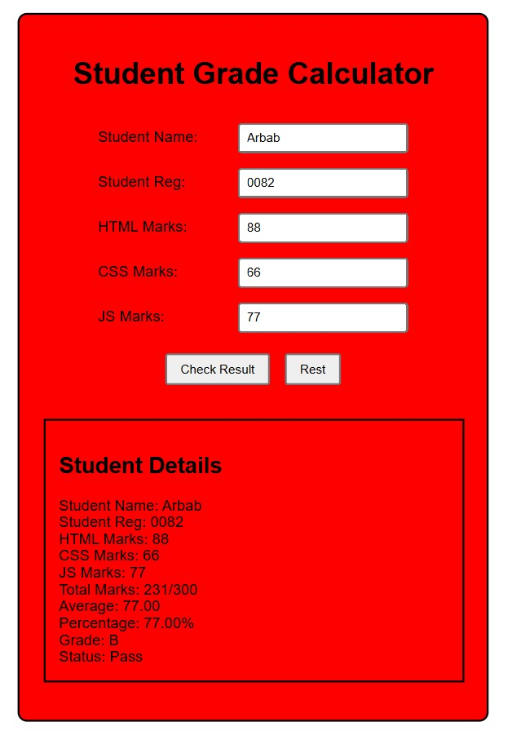

CONCLUSION

The Student Grade Calculator successfully provides a simple and interactive way to calculate and display student results. It uses HTML for structure, CSS for proper design and alignment, and JavaScript for calculations and decision-making. The program calculates total marks, average, percentage, grade, and pass or fail status. The Check Result and Restart buttons make the application easy to use. Overall, this project helps demonstrate the practical use of basic web development concepts such as forms, styling, functions, conditions, and DOM manipulation.

